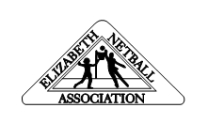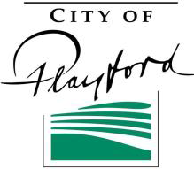
ELIZABETH
NETBALL
ASSOCIATION INC

NOTICE
In accordance with the Elizabeth Netball Association Constitution, notice is hereby given that the
Annual General Meeting
will be held on
Monday 4th March 2024
7.30pm
At Argana Park Clubrooms, Mavros Road, Elizabeth Downs

Any nominations, agenda items and notices of motion are to be received by the Secretary by 4pm, Monday 5th February 2024
AGM papers will be distributed in the following week

